**Multiple Choice questions – Airbnb and Tennis**

For the Basic Module of Tableau for Teaching Resources

Using the Airbnb Chicago dataset:

Give students the “Airbnb_Chicago” Tableau data file for these questions:

Appropriate any time after Basic Module, Topic **2** (Connecting to Data):

1. How many Airbnb listing in Chicago have a price of more than $3000?
   1. 0
   2. 1
   3. 2
   4. 3
   5. 4

1. What Chicago neighbourhood(s) contain Airbnb listings with a price of more than $3000?
   1. only Near North Side
   2. only Lincoln Park
   3. both Near North Side and West Town
   4. both Lincoln Park and Avondale
   5. both Lincoln Park and Uptown

1. Which Chicago neighbourhood receives the highest average number of reviews per month?
   1. West Town
   2. Lake View
   3. Ohare
   4. Roseland
   5. None of the Above

1. How many Shared Rooms are available in Chicago for a price of over $300?
   1. 1
   2. 2
   3. 3
   4. 22
   5. 32

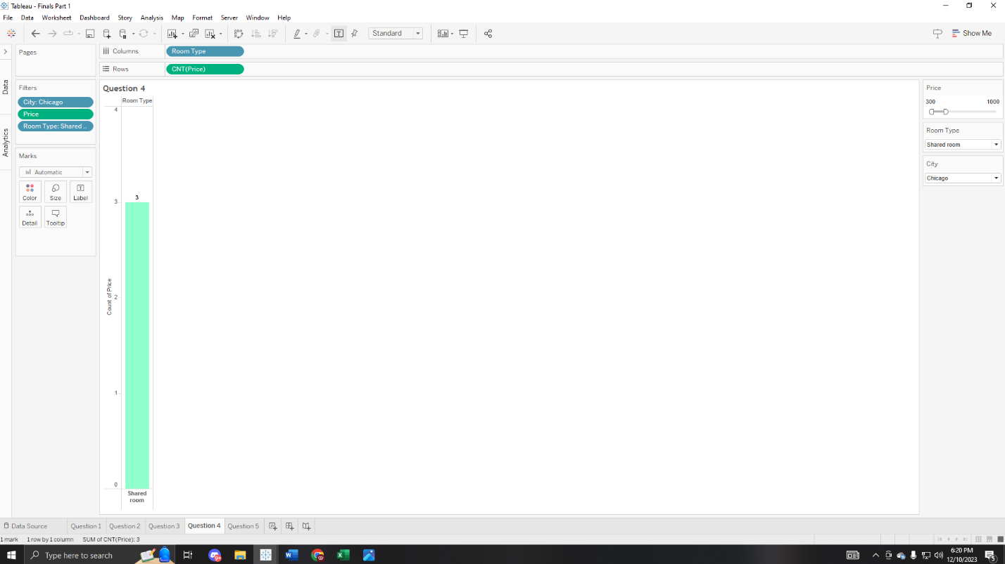

Appropriate any time after Basic Module, Topic **9** (Maps Intro) – requires map layers to locate MDW:

1. What is the Room Type and Price of the Airbnb listing that is immediately to the west of MDW airport?
   1. Private Room for $50 per night
   2. Private Room for $70 per night
   3. Private Room for $75 per night
   4. Entire Home/Apt for $110 per night
   5. Entire Home/Apt for $136 per night

Using the ATP Tennis dataset:

Give students the “ATP_Tennis” Tableau data file for these questions:

Appropriate any time after Basic Module, Topic **2** (Connecting to Data):

1. How many players had more than 50 wins in this dataset?
   1. 0
   2. 3
   3. 8
   4. 11
   5. None of the Above

Appropriate any time after Basic Module, Topic **5** (Basic Charts):

1. Consider the 11-month stretch consisting of Jan-Nov 2015. In how many of these 11 months did Federer win more Completed matches than Berdych? Do not include wins that are described as Retired, Sched, or Walkover – only Completed matches.
   1. 5
   2. 6
   3. 9
   4. 10
   5. 11

1. Which three players had the most wins on hard courts in this dataset?
   1. Djokovic, Berdych, and Murray
   2. Djokovic, Nadal, and Murray
   3. Djokovic, Federer, and Isner
   4. Djokovic, Murray, and Federer
   5. Federer, Djokovic, and Wawrinka

